Happy governments game
Game instructions
- Two to four players are involved.
- Each player receives four playing cards.
- Place the remainder of the pack in the middle.
- Players take it in turns to pick up from the middle pile.
- Players must discard a card each time (that is, at the end of their turn, they have four cards).
- The object of the game is to collect: a federal, state/territory or local government card; its role, its set of responsibilities and an illustration to match — a happy government. Note: the illustration must match one of the dot points on the responsibilities card (see below).
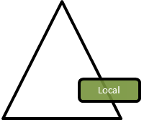 | Role:  - to make laws which reflect community needs and ensure they can govern their area | Responsibilities:  - swimming pools  - protection of historic places  - pet control | Pet control  
Note: Pet control (in this case, a barking dog) is a responsibility of the local government whose role is to make laws that reflect community needs and ensure they can govern their area.
- The multiple-levels-of-government card is the wild card. It can to be used to represent any level of government needed to win the game OR it can be used to prevent another person from going out by presenting it to them. This would mean they would have five cards and therefore cannot go out until the next round, when they will be able to throw out a card in their hand.
- If the cards have been used and there is no winner, turn the pack over and start again.

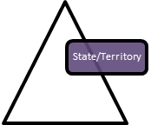 | 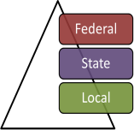 | 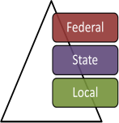
 | 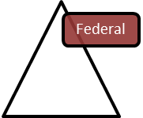 | 
 |  | 

Responsibilities:  - defence forces  - post  - family support  - quarantine | Role: to make laws for the whole of the country. | Role: to make laws for the whole of the country.
 |  | 
 |  | 

Role: to make laws for the whole of the country | Role: to make laws for the whole of the country | Role: to make laws that are enforced within their own state or territory
Role: to make laws that are enforced within their own state or territory | Role: to make laws that are enforced within their own state or territory | Role: to make laws that are enforced within their own state or territory
Role: to make laws that reflect community needs and ensure they can govern their area | Responsibilities:  - telecommunications  - Medicare  - foreign affairs  - immigration | Responsibilities:  - income tax  - Medicare  - quarantine  - immigration

Responsibilities:  - income tax  - immigration  - customs  - post | Responsibilities:  - income tax  - family support  - defence force  - quarantine | Role:  to make laws that reflect community needs and ensure they can govern their area
Role:  to make laws that reflect community needs and ensure they can govern their area | Role:  to make laws that reflect community needs and ensure they can govern their area | Responsibilities:  - swimming pools  - local roads  - pet control  - protection of historic places
Responsibilities:  - rubbish bins  - street signs  - local parks  - pet control | Responsibilities:  - rubbish bins  - protection of natural areas  - local parks  - swimming pools | Responsibilities:  - swimming pools  - protection of historic places  - pet control  - street signs
Responsibilities:  - transport  - police services  - education  - ambulance | Responsibilities:  - community  services  - sport and recreation  - education  - driver’s licence | Responsibilities:  - health  - sport and recreation  - transport  - police services
Responsibilities:  - police services  - ambulance  - health  - community services | 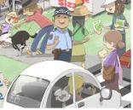  police services | 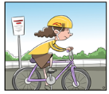  transport: bike helmets
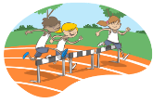  sport and recreation | 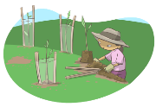  local parks | 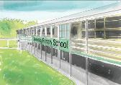  education

swimming pools  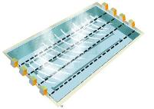 |   telecommunications | 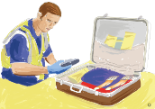  customs
  family support |   pet control | local roads  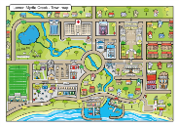
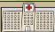  health | Responsibilities:  - income tax  - family support  - defence force  - quarantine | post office  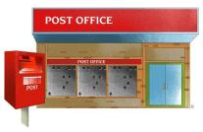

Responsibilities:  - rubbish collection  - street signs  - swimming pools  - pet control | protection of historic places  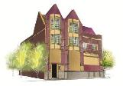 | street signs  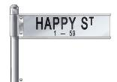
community services  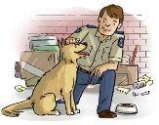 | ambulance  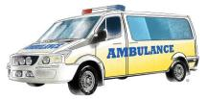 | transport: driver’s licence  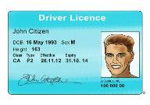
Responsibilities:  - community service  - education  - ambulance  - transport | Responsibilities:  - rubbish collection  - street signs  - swimming pools  - local roads | Responsibilities:  - post  - immigration  - defence force  - family support

Responsibilities:  - rubbish collection  - street signs  - swimming pools  - pet control | Responsibilities:  - post  - immigration  - defence force  - family support | 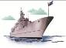  defence force: navy, army and air force  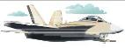  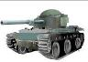
rubbish collection  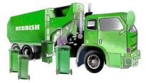 | quarantine  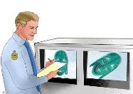 | immigration: passports  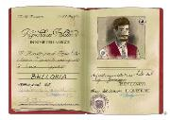
Responsibilities:  - community service  - education  - ambulance  - transport | Responsibilities:  - quarantine  - post  - income tax  - defence force | Responsibilities:  - post  - immigration  - defence force  - Medicare

